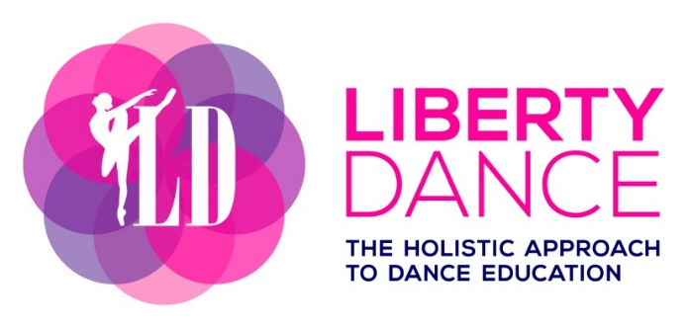
www.libertydance.org (647) 567 – 1886 admin@libertydance.org
CAPSUL STUDIO 25 Liberty Street, Suite 200, Toronto ON M6K 1A6
ARTSCAPE YOUNGPLACE 180 Shaw Street, LL (Movement Studio), Toronto ON M6J 2W5
MAILING ADDRESS 715-150 East Liberty Street, Toronto ON M6K 3R5

REGISTRATION: (Returning dancer –include name + updated contact info)
Name of Dancer: _______________________________________
Birth Date: _________________________________________________
Address: ___________________________________________________
Phone:_____________________________________________________
Email:_____________________________________________________
Special considerations
* Include any health-related conditions including respiratory issues and allergies:
__________________________________________________________

Name of Parent/Guardian: __________________________________________________________
Address (if different from above): __________________________________________________________
__________________________________________________________
Contact (if different from above):
(phone) ____________________________________________________
(email) _____________________________________________________
Emergency Contact:
Name/Relationship: ____________________________________________
Phone/Email: ________________________________________________
HYBRID GROUP CLASS (In-Studio or Online) JANUARY 10TH – MARCH 9TH:
SUNDAYS: ARTSCAPE YOUNGLACE – LOWER LEVEL – MOVEMENT STUDIO
*No class Sunday, February 19th
□ 10:00-11:00 Grade 2-3 Ballet (age 7-9)
□ 11:00-12:00 Jr Jazz & Tap (age 7-9)
□ 12:00-1:00 Adult Ballet (age 18+)
TUESDAYS: CAPSUL STUDIO – 2ND FLOOR – UNIT 200
□ 5:30-6:30 Jr-Inter Hip Hop (age 7-12)
□ 6:30-7:30 Jr-Inter Acro (age 7-12)
THURSDAYS: CAPSUL STUDIO – 2ND FLOOR – UNIT 200
□ 4:30-5:00 Creative Dance (age 2-3)
□ 5:00-5:30 Pre-Primary Ballet (age 4-5)
□ 5:30-6:30 Primary/Grade 1 Ballet (age 6-7)

GROUP CLASS FEES (HST included):
CLASS DURATION | TERM FEE | INSTALLMENT #1  DUE JAN 10TH | INSTALLMENT #2 DUE FEB 7TH
THURSDAY  30 min | $198 | $88 | $110
TUES/ THURS  60 min | $252 | $112 | $140
SUNDAY  60 min | $196 | $84 | $112

PRIVATE & SEMI-PRIVATE CLASSES:
Appointments are available upon request, outside of the group classes offered. These classes can be in-studio or online. The fees outlined below are based on a private class with 1 dancer. For 2 dancers in a semi-private class, the fees below are split between the dancers attending.
LOCATION | 90 min class | 75 min class | 60 min class | 45 min class | 30 min class
ONLINE | $105 | $87.50 | $70 | $52.50 | $35
IN-STUDIO | $225 | $187.50 | $150 | $112.50 | $75

REGISTER FOR THE FOLLOWING CLASSES (please list):
□
□
□

METHOD OF PAYMENT: _____ CASH _____E-TRANSFER _____CREDIT CARD
Name on credit card: _________________________________________________
Address/Postal Code: _________________________________________________
Credit Card #: ______________________________________________________
Expiry: _______________
Security Code (back of card): __________
EARLY CANCELLATION:
Registering for the term allows for two missed classes that can be utilized for future credit. Classes missed beyond this amount will not be credited.
REFUND POLICY:
Fees paid are non-refundable; however, if a special circumstance occurs it will be under the discretion of Liberty Dance to give a partial refund. Applicable doctor’s note may provide a 50% refund in such cases of injury or illness.
INTEREST CHARGES:
Fees are due on the deadline listed above. Interest charges are applied at 1% per day if payment is received after due date. For example, if you owe $100 by Dec 1st, and you make a payment by Dec 5th, your total interest owed is $4 added to your original payment.
Agreement of Release & Waiver of Liability:
I, _____________________________, hereby agree to the following:
(Name of Participant or Guardian)

I understand participation in a dance class at Liberty Dance requires physical exertion causing strenuous activity, which may cause a risk or hazard to physical injury.
I understand it is the participant’s responsibility to consult a physician prior to partaking in any class at Liberty Dance to recognize that there are no medical conditions present, which may prevent participation.
I understand that every class held at Liberty Dance is conducted in a safe manner by fully qualified dance instructors, and agree to take full responsibility for any risks, injuries, or damages that may occur as result of participation in class.
I will waive any claim I may have against Liberty Dance or its instructors for injury or damage that may occur as a result of participating in a class at Liberty Dance.
I have read and understand the studio policies, special considerations, refund and interest policy, terms, release, and waiver of liability, and fully understand its contents.

_______________ _________________________________
Date Signature of Participant or Guardian

THANK YOU FOR YOUR SUPPORT!

