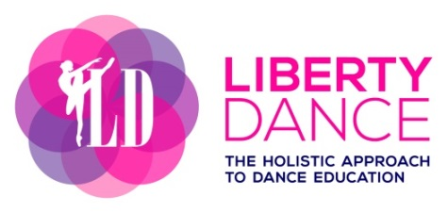
Uniform Policies

Dance Style: | Clothing: | Shoes: | Hair:
Ballet:  Children & Youth  Adult | Bodysuit  Skirt (optional)  Ballet tights  Open to athletic or ballet apparel | Ballet shoes in canvas or leather (split or full sole)  Ballet shoes or similar | Bun with secured pins  Optional
Jazz: | Bodysuit or tank top  Leggings | Jazz shoes | Bun or ponytail – no loose hair
Tap: | See Jazz | Tap shoes | See Jazz
Acro: | See Jazz | Barefeet | See Jazz
Hip Hop: | Loose fitting clothing | Running shoes (clean) | Optional

